 | Price | Size (mm) | Weight (g) | RAM | Data Ports | Video Ports | Power | Data Other
Rasp. Pi Zero W | $10-$15 | 30/65/5 | 9-12 | 512MB | 1x microUSB,  GPIO pins | GPIO pins,  1x miniHDMI | 180mA (5v?) | Built in Wifi & Bluetooth
Rasp. Pi 2 | $35 | 56.5/85.6/17 | 45 | 1GB | 4x USB,  GPIO pins | GPIO pins,  1x HDMI | 800mA  (5v?)
Rasp. Pi 3 | $35 | 56.5/85.6/17 | 45 | 1GB | 4x USB,  GPIO pins | GPIO pins,  1x HDMI | 1.34A  @ 5V | Built in Wifi & Bluetooth
Rasp. Pi 3 A+ | $25 | 65/56/11 | 29 | 512MB | 1x USB,  GPIO pins | GPIO pins,  1x HDMI | ??? | Built in Wifi  & Bluetooth
Rasp. Pi 3 B+ | $35 | 56.5/85.6/17 | 45 | 1GB | 4x USB,  GPIO pins | GPIO pins,  1x HDMI | 1.13A  @ 5V | Built in Wifi & Bluetooth
Rasp. Pi 4 B | $35+ | 56.5/85.6/11 | 46 | 1-4GB | 2x USB,  2x USB3,  GPIO pins | GPIO pins,  2x microHDMI | 1.25A  @ 5V | Built in Wifi & Bluetooth

GPIO: https://www.raspberrypi.org/documentation/usage/gpio/
General FAQ: https://www.raspberrypi.org/documentation/faqs/

Display through GPIO: https://www.raspberrypi.org/forums/viewtopic.php?f=91&t=94424

https://socialcompare.com/en/comparison/raspberrypi-models-comparison

Supported OS (Officially?): https://www.raspberrypi.org/downloads/
- Raspbian
- Ubuntu MATE
- Ubuntu Core
- LibreElec
- RISC OS
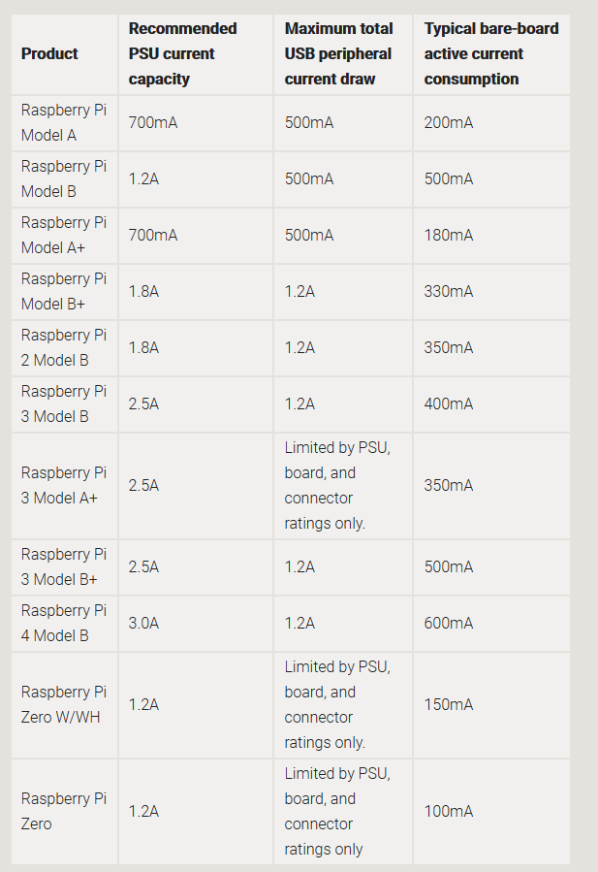
Power: https://www.raspberrypi.org/documentation/faqs/#pi-power

Video out for Raspberry Pi W:
microHDMI
GPIO pins
https://learn.adafruit.com/introducing-the-raspberry-pi-zero/video-outputs
https://www.adafruit.com/product/2315
https://www.adafruit.com/product/1480

Problem, how to hook up 2 displays to 1 pi?

